Knee Rehabilitation Programme
Here are a few exercises that you can try in order to help relieve the pain in your knee and to begin strengthening to surrounding muscles.
If you do have any questions please don’t hesitate to contact me, I will be happy to further assist you!
- Flexion + Extension
- Quadriceps contraction
- Step ups
- Leg Abductors
- Clam exercise
- Prone hip extensions
Exercises | Description | Reps x sets
Flexion + Extension | Sitting comfortably on the floor with your back against a wall. Begin with your legs straight our in front of you and then bending on knee up towards your chest dragging your heel along the floor. | Slowly bending and extending the leg for a count of 3 seconds each way. Repeat 10 times on each leg x2 sets.
Quadriceps contraction | Staying sat on the floor with both legs straight, place a rolled up towel underneath one knee so it is between the leg and the floor. Push down onto the towel as if your straightening your knee. Pull your toes and foot towards you, so that you feel a calf stretch and so your heel lifts off the floor. | Hold the straightened position for 5 seconds. Repeat this 10 times on each leg.
Step ups | Using a small step. If needed hold onto something to keep balance. Step up onto your step with one foot, follow it with the other foot, then step off the step in the same order. | 10-12 steps on each leg. Repeat 2x with 1 minute rest in between.
Leg Abductors | Lying comfortably on your side with your arm supporting your head. With straight legs lift the top leg up roughly 45 degrees from the bottom leg and lower down. | 10 x 2-3 each leg
Clam Exercise | Staying in the same position, bend your knees (to a comfortable position) and keep feet together. Now lift your top knee up away from the bottom knee, ensuring your hips are staying level and then close. | 10 x 2-3 each leg
Prone Hip Extensions | Lying face down, legs straight, lift one leg up from the hip and back down again. Only lift from the hips, try not to bend your knee. You may possibly feel this in your lower back, however that is just your muscles working. | 10 x 2 each leg

Please note, if any of these exercises cause pain please stop doing them. Whilst doing these exercises please record how you are feeling whilst doing them.
These exercises should be performed at least once a day or every other day.
Please let me know if you have any questions.

Photos of the Exercises
- Flexion + Extension
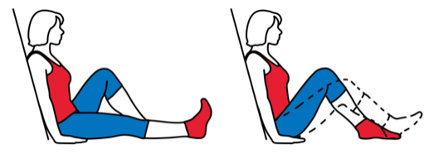
- Quadriceps Contraction

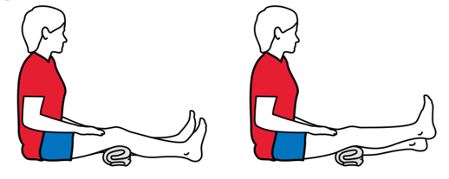

- Step ups
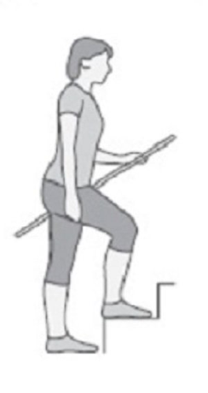

- Leg Abductors
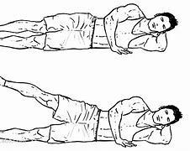

- Clam Exercise
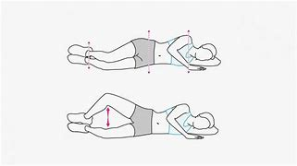

- Prone hip extensions
