Shoulder Dislocation Rehab Plan
For the first week you need to work on your range of movements; flexion, extension, abduction/adduction, internal and external rotation. This can be done either using a broom/large stick to help guide your injured arm with your non-injured arm, or if you are able to move your injured arm by itself then do it by itself. Only go to a point before pain. You will see an increase within the first week. Do 10 reps x 2-3 sets, 1-2 time per day (possibly morning and night).

More exercises

Pendulum swings- leaning on a table with your uninsured arm, flat back leaning forward, make circles with your injured arm that’s reaching the floor. 10 mini circles both ways x 2 sets. 1-2 times per day.

Isometrics
Do not perform any of these movements if they cause pain.

External rotation- using a wall or door frame. Keeping your elbow into your side, push the back of your hand against the solid wall causing tension. Hold for 10-15 seconds and repeat 2-3 times. 1-2 times per day

Internal rotation- using a door frame. Same stance as external rotation but push your palm of your hand into the wall, keeping your elbow into your side. Hold for 10-15 seconds and repeat 2-3 times. 1-2 times per day

Flexion- using a wall, bend your arm at your elbow, keeping the elbow into your side. Face the wall and push your fist into the wall. Hold for 10-15 seconds, x2-3 sets, 1-2 times per day.

Extension- With your back to the wall, push your elbow into the wall. Hold for 10-15 seconds, x 2-3 sets, 1-2 times per day.

All of these exercises can be performed straight away, only if you don’t feel pain whilst doing them. Make sure your apply ice when the pain occurs and rest as much as possible.

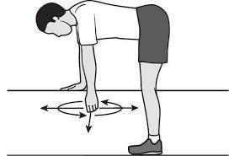
Pendulum swings

